
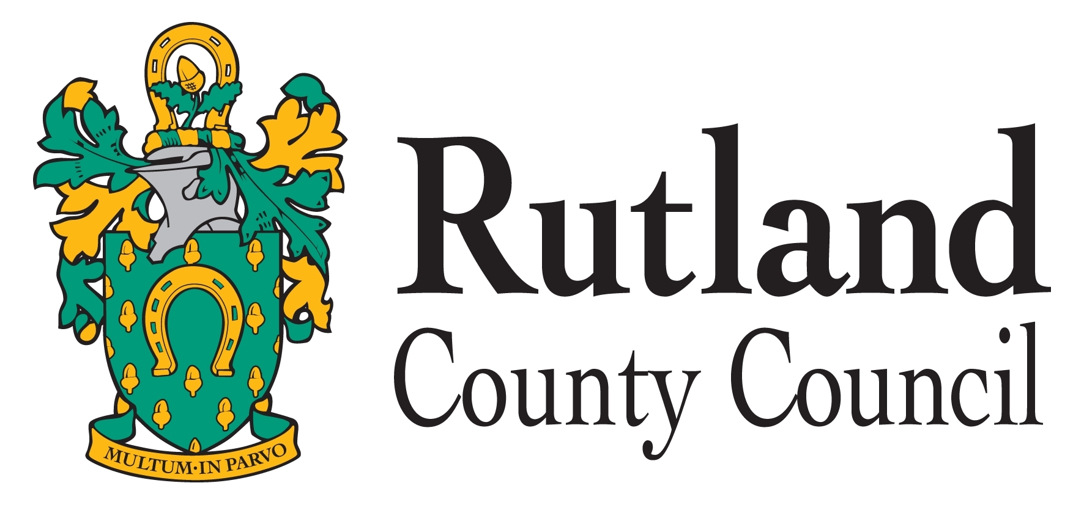


7th September 2012

The Right Hon Jeremy Hunt MP
The Secretary of State for Health
Department of Health
Richmond House
79 Whitehall
London
SW1A 2NS

Dear Secretary of State for Health

Glenfield Hospital – Children’s Congenital Heart Surgery and Children’s Extracorporeal Membrane Oxygenation (ECMO) Services

We wrote to your predecessor, Andrew Lansley, on 23rd August 2012 indicating that the Leicester, Leicestershire and Rutland Health Overview and Scrutiny Committee was extremely concerned about the decision to move Children’s Congenital Heart Surgery and Children’s ECMO Services from the Glenfield Hospital in Leicester to Birmingham Children’s Hospital.

In the letter of 23rd August, we advised that it was our intention to test our evidence with the Joint Committee of Primary Care Trusts (JCPCT) prior to making a formal referral. We have since been advised that the referral made by Lincolnshire Health Scrutiny Committee is now with the Independent Reconfiguration Panel (IRP) and that the IRP is likely to be providing you with an interim view by 21st September. In view of this and the fact that the only date the JCPCT has offered is 29th October, the Joint Committee has decided to make a formal referral now, so that the evidence it has gathered can be referred to and assessed by the IRP alongside the referral from Lincolnshire. The formal referral document is attached.

The Committee was also made aware that the JCPCT is meeting on 4th October and has agreed to send a copy of this letter and the formal referral to it.

The decision to move Children’s Congenital Heart Surgical and ECMO Services has not been well received and you should also be aware of the depth of feeling as evidenced by:

- The support of Leicester and Leicestershire MPs of all parties;
- The support from councillors of all parties in Leicester, Leicestershire and Rutland and from the wider representative body of East Midlands Councils;
- The concerns expressed by the LINk and patient groups including an online petition that has to date attracted over 60,000 signatures.

We trust you will look carefully at the decision and impact this would have, not only on children with congenital heart disease, but also the wider impact this would have on the viability of other services such as Children’s Paediatric Intensive Care Unit and research activity. The Committee firmly believes that the decision to move the Children’s Congenital Heart Service and ECMO is not in the best interest of the local health service and the population it serves.
Yours sincerely
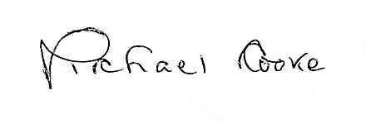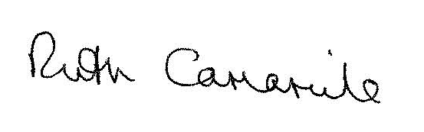
Michael Cooke Ruth Camamile

Leicester, Leicestershire and Rutland Joint Health and Overview Scrutiny Committee.

